Real –Time Driver Drowsiness System

Shantanu Pingale, Kedar Pravin Dhokarikar, Sara Dixit, Kartik Tiwari, Sangeeta Malviya

DEPARTMENT OF INFORMATION TECHNOLOGY AND MCA

***Abstract*—** **This project is aimed towards developing a prototype of drowsiness detection system. This system is a real time system which captures image continuously and measures the state of the eye according to the specified algorithm and gives warning if required.For DOD the per closure value of eye is considered. So when the closure of eye exceeds a certain amount then the driver is identified to be sleepy for system we are using python IDE in which we are working on open CV library and D library**

***Keywords*** *—**Detection of drowsiness,*

1. INTRODUCTION

Car accident is the major cause of death in which around 1.3 million people die every year. Majority of these accidents are caused because of distraction or the drowsiness of driver. Construction of high-speed highway roads had diminished the margin of error for the driver. The countless number of people drives for long distance every day and night on the highway. Lack of sleep or distractions like the phone call, talking with the passenger, etc. may lead to an accident. To prevent such accidents we propose a system which alerts the driver if the driver gets distracted or feels drowsy. Facial landmarks detection is used with help of image processing of images of the face captured using the camera, for detection of distraction or drowsiness. This whole system is deployed on portable critical and the approach decided on is Heuristic assessment. Heuristic Evaluation provides a guideline to inspect and identify the problems of a consumer interface. That hardware which can be easily installed in the car for use. However nowadays, robust real-time facial landmark detectors that capture most of the characteristic points on a human face image, including eye corners and eyelids, are available, see Fig. 1. Most of the state-of-the-art landmark detectors formulate a regression problem, where a mapping from an image into landmark positions or into other landmark is learned. These modern landmark detectors are trained on “in-the-wild datasets” and they are thus robust to varying illumination, various facial expressions, and moderate non-frontal head rotations. An average error of the landmark localization of a state-of-the-art detector is usually below five percent of the inter-ocular distance. Recent methods run even significantly super real-time.

1. MATERIALS
2. *Hardware*

*1.laptop camera*

*b.Software*

*1.Python IDE*

*2.DLIB*

*3.scipy*

*4.OpenCV*

III. METHODOLOGY

We propose to exploit state-of-the-art facial landmark detectors to localize the eyes and eyelid contours. From the landmarks detected in the image, we derive the eye aspect ratio (EAR) that is used as an estimate of the eye opening state. Since per frame EAR may not necessarily recognize the eye blinks correctly, a classifier that takes a larger temporal window of a frame into account is trained.

Block diagram for traverse the methodology.

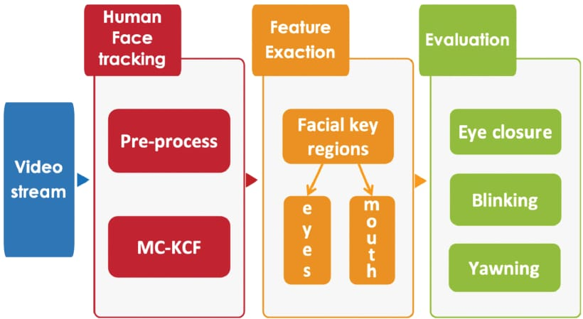

1. **Description**

For every video frame, the eye landmarks are detected. The eye aspect ratio (EAR) between height and width of the eye is computed.

EAR=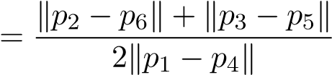, where p1 to p6 are the 2D landmark locations. The EAR is mostly constant when an eye is open and is getting close to zero while closing an eye. It is partially person and head pose insensitive. Aspect ratio of the open eye has a small variance among individuals and it is fully invariant to a uniform scaling of the image and in-plane rotation of the face. Since eye blinking is performed by both eyes synchronously, the EAR of both eyes is averaged. An example of an EAR signal over the video sequence.

1. **Classification**

It generally does not hold that low value of the EAR means that a person is blinking. A low value of the EAR may occur when a subject closes his/her eyes intentionally for a longer time or performs a facial expression, yawning, etc., or the EAR captures a short random fluctuation of the landmarks. Therefore, we propose a classifier that takes a larger temporal window of a frame as an input. For the 30fps videos, we experimentally found that ±6 frames can have a significant impact on a blink detection for a frame where an eye is the most closed when blinking. Thus, for each frame, a 13-dimensional feature is gathered by concatenating the EARs of its ±6 neighboring frames. This is implemented by a linear SVM classifier (called EAR SVM) trained from manually annotated sequences.A ground-truth blink is defined by its beginning frame, peak frame and ending frame. The second database Eye blink8 is more challenging. It consists of 8 long videos of 4 subjects that are smiling, rotating head naturally, covering face with hands, yawning, drinking and looking down probably on a keyboard. These videos have length from 5k to 11k frames, also 30fps, with a resolution 640 × 480 pixels and an average IOD 62.9 pixels. They contain about 50 blinks on average per video. Each frame belonging to a blink is annotated by half-open or close state of the eyes. We consider half blinks, which do not achieve the close state, as full blinks to be consistent with the ZJU.

**3. Eye Blink Detector Evaluation**

We evaluate on two standard databases with ground-truth annotations of blinks. The first one is ZJU consisting of 80 short videos of 20 subjects. Each subject has 4 videos: 2 with and 2 without glasses, 3 videos are frontal and 1 is an upward view. The 30fps videos are of size 320 × 240 px. An average video length is 136 frames and contains about 3.6 blinks in average. An average IOD is 57.4 pixels. In this database, subjects do not perform any noticeable facial expressions. They look straight into the camera at close distance, almost do not move, SVM classifiers are tested with both landmark detectors Chehra and Intraface .Eye aspect ratio graph is as following.

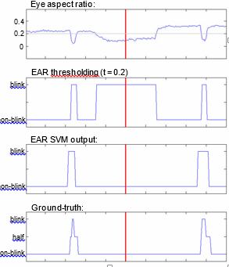

Figure 1: Example of detected blinks where the EAR thresholding fails while EAR SVM succeeds. The plots of the eye aspect ratio EAR in Eq., results of the EAR thresholding (threshold set to 0.2), the blinks detected by EAR SVM and the ground truth labels over the video sequence. Input image with detected landmarks (depicted frame is marked by a red line).

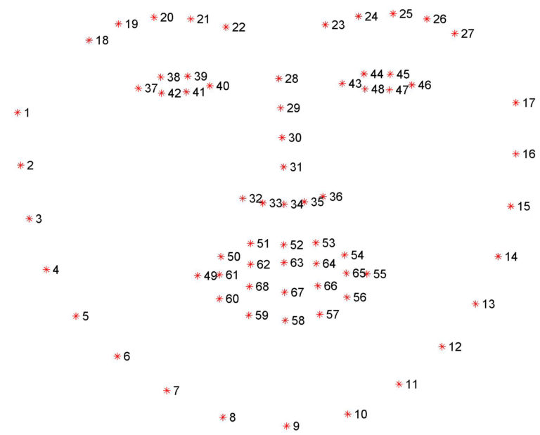

Fig 2. Co-ordinates for eye facial landmarks

This fig. shows how facial landmarks are done by using library.

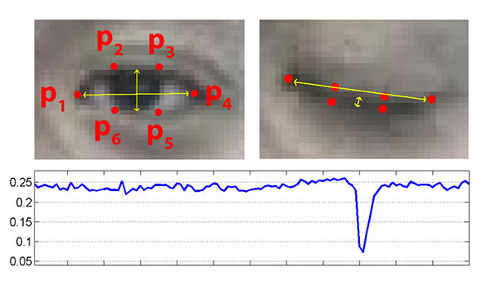

This is the final eye asoect ratio where the second diagram showing the sudden low graph which result in turn on the alarm.

IV. RESULT AND DISCUSSION

This must be helping system for automobile industries and government of India to reduce the car accident on roads. This system allows you to drive safe only.

V. LIMITATIONS

1. Limitations are like we cannot use laptop as a system for camera purpose.
2. This system can be costly.
3. Some driver will face difficulty in case of error calculation and giving alarm.

.

VI. FUTURE SCOPE

1. This is our first step towards the evolution of better model
2. We will try to implement this idea on APP based system
3. We are also trying to send the live location project can be implemented in the form of mobile application to reduce the cost of hardware.
4. This project can be integrated with car, so that automatic speed control can be imparted if the driver is found sleeping.

VII. CONCLUSION

A real-time eye blink detection algorithm was presented. We quantitatively demonstrated that regression-based facial landmark detectors are precise enough to reliably estimate a level of eye openness. While they are robust to low image quality (low image resolution in a large extent) and in-the-wild

57.38

51.6

45.9

40.2

34.4

28.7

23.0

17.2

11.5

5.7

0

0.1

0.2

0.3

0.4

0.5

0.6

0.7

0.8

0.9

1

AUC

Chehra SVM

Intraface SVM

IOD [px]

Figure 3: Accuracy of the eye blink detector (measured by AUC) as a function of the image resolution (average IOD) when subsampling the ZJU dataset.

phenomena as non-frontality, bad illumination, facial expressions, etc.

State-of-the-art on two standard datasets was achieved using the robust landmark detector followed by a simple eye blink detection based on the SVM. The algorithm runs in real-time, since the additional computational costs for the eye blink detection are negligible besides the real-time landmark detectors.

The proposed SVM method that uses a temporal window of the eye aspect ratio (EAR), outperforms the EAR thresholding. On the other hand, the thresholding is usable as a single image classifier to detect the eye state, in case that a longer sequence is not available.

VIII. AKNOWLEDGEMENT

We all are very thankful to our guide Prof. Deepali Deshpande for guiding us and giving us right direction towards the completion of our Project. We would also like to thanks Prof. Debabrata Swain and Director of VIT College.

Ix. REFERENCES

[1] Miaou, “Study of Vehicle Scrap page Rates,” Oak Ridge National Laboratory, Oak Ridge, TN, S.P.,April 2012.

[2] Wreggit, S. S., Kim, C. L., and Wierwille, W. W., Fourth Semi-Annual Research Report”, Research on Vehicle-Based Driver Status Performance Monitoring”, Blacksburg, VA: Virginia Polytechnic Institute and State University, ISE Department, January 2013.

[3] Bill Fleming, “New Automotive Electronics Technologies”, International Conference on Pattern Recognition, pp. 484- 488,December 2012.

[4] Ann Williamson and Tim Chamberlain,“Review of on-road driver fatigue monitoring devices”, NSW Injury Risk Management Research Centre, University of New South Wales, , July 2013.